FAS 4475 Group 5 Part C
Alexandra Schol, Rachel Sollers, Marquita Taylor, and Anjelika Tremblay
Professor Filerino
FAS 4475
Berkeley College

FAS 4475 Group 5 Part C
Product Spec Sheet and Content
STYLE SPECIFICATION SHEET

Front
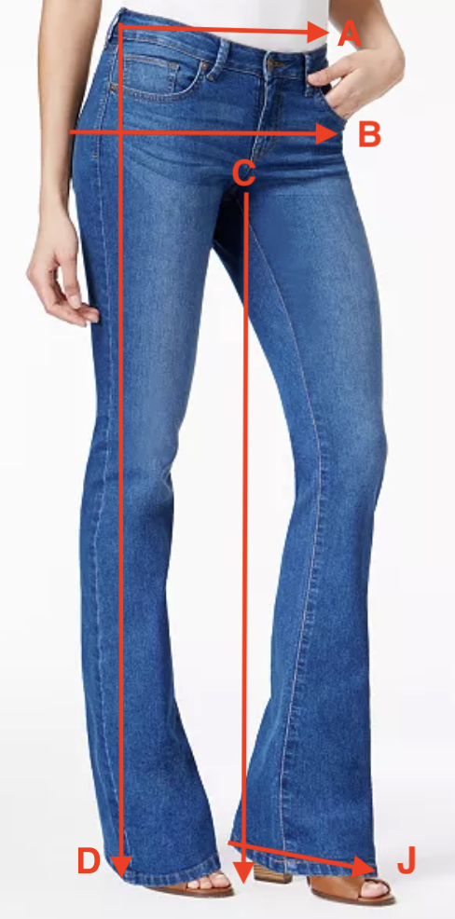

Style #: _WBC-111___ Design #: __HRGLS-111_____
Season: __Fall 2019___ Date: __1 Mar 2019________
Description: West Boot Cut Jean Color: True Blue Wash

Fabric #: __DM-001________________________
Type/Fiber content: ___96% cotton, 4% Lycra_____
Finish: __True Blue Wash- piece dyed________________
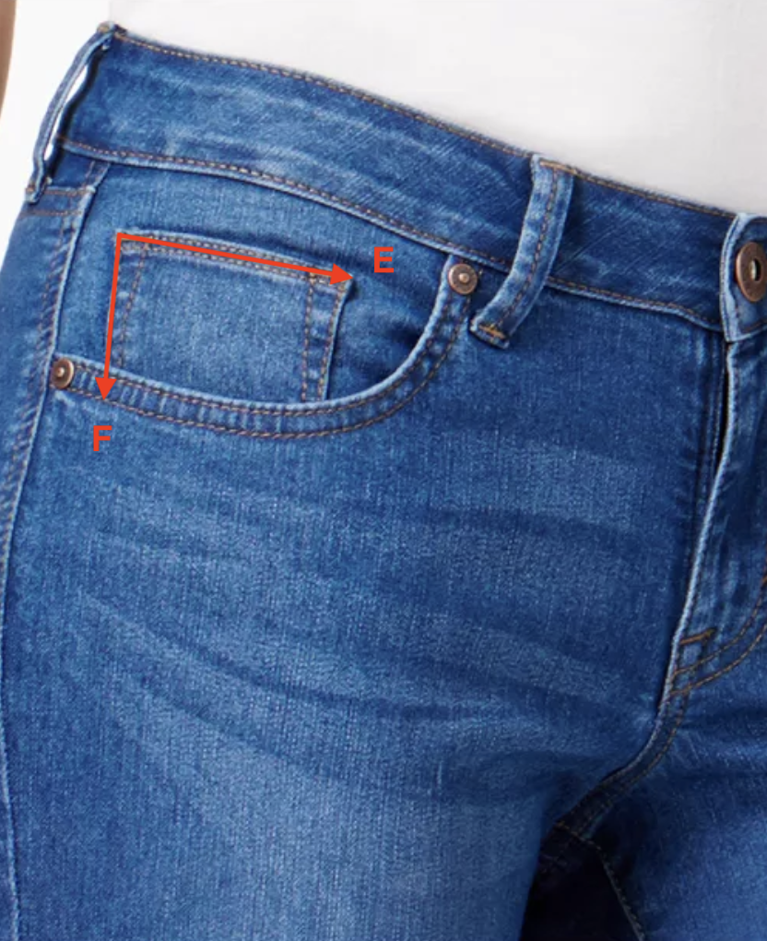
Size:  Line | 24 | 25 | 26 | 27 | 28 | 29 | 30 | 31 | 32
A | 24” | 25” | 26” | 27” | 28” | 29” | 30” | 31” | 32”
B | 32”  33”  34” | 33.5  34.5  35.5 | 34.5  35.5  36.5 | 36  37  38 | 37  38  39 | 38.5  39.5  40.5 | 40  41  42 | 41  42  43 | 42.5  43.5  44.5
C | 32” | 32” | 32” | 32” | 32” | 32” | 32” | 32” | 32”
D | 40” | 40” | 40” | 40” | 40” | 40” | 40” | 40” | 40”
E | 2.5” | 2.5” | 2.5” | 2.5” | 2.5” | 2.5” | 2.5” | 2.5” | 2.5”
F | 2.5” | 2.5” | 2.5” | 2.5” | 2.5” | 2.5” | 2.5” | 2.5” | 2.5”
G | 5” | 5” | 5” | 5.5” | 5.5” | 5.5” | 6” | 6” | 6”
H | 5” | 5” | 5” | 5.5” | 5.5” | 5.5” | 6” | 6” | 6”
I | 2” | 2” | 2” | 2.25” | 2.25” | 2.25” | 2.5” | 2.5” | 2.5”
J | 19” | 19” | 19” | 20” | 20” | 20” | 21” | 21” | 21”

Back
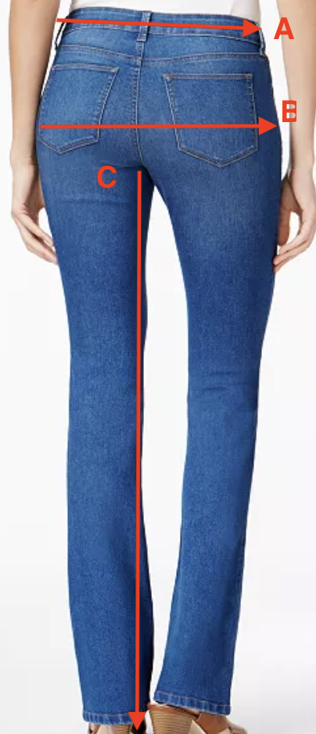
Findings/Trim
 | Type/Number | Color | Size | Amount
Thread | Singer 67120 | Old Gold | Heavy Duty | 300 meters
Rivets | RV9295D | Antique Brass | 9.2mm | 4
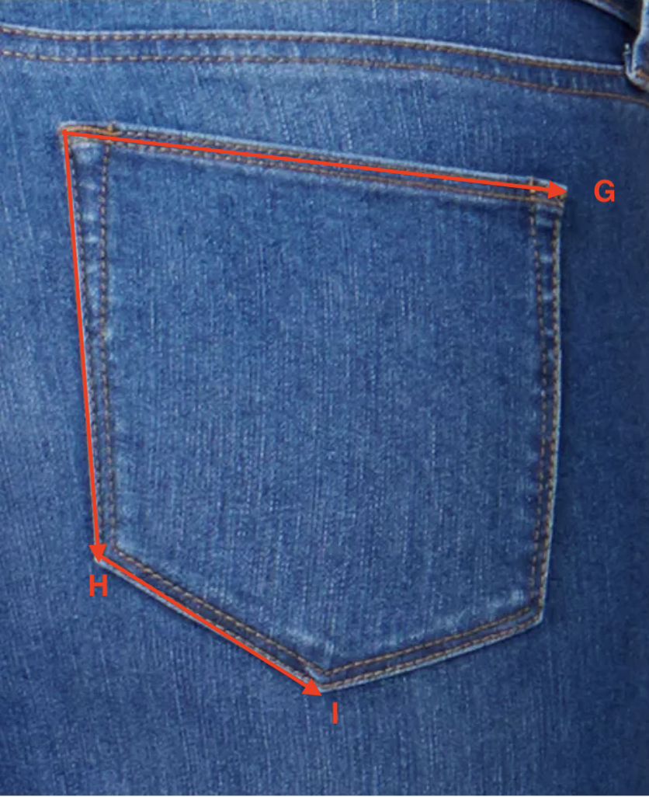
Hangtag: | Label:
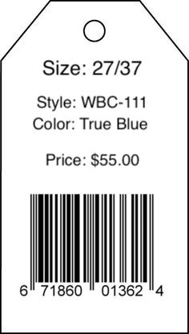 | 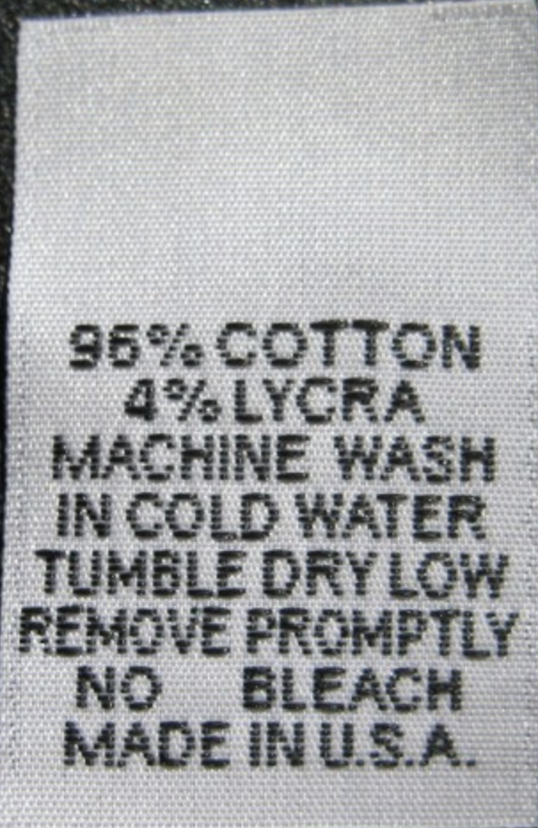

STYLE SPECIFICATION SHEET

Front
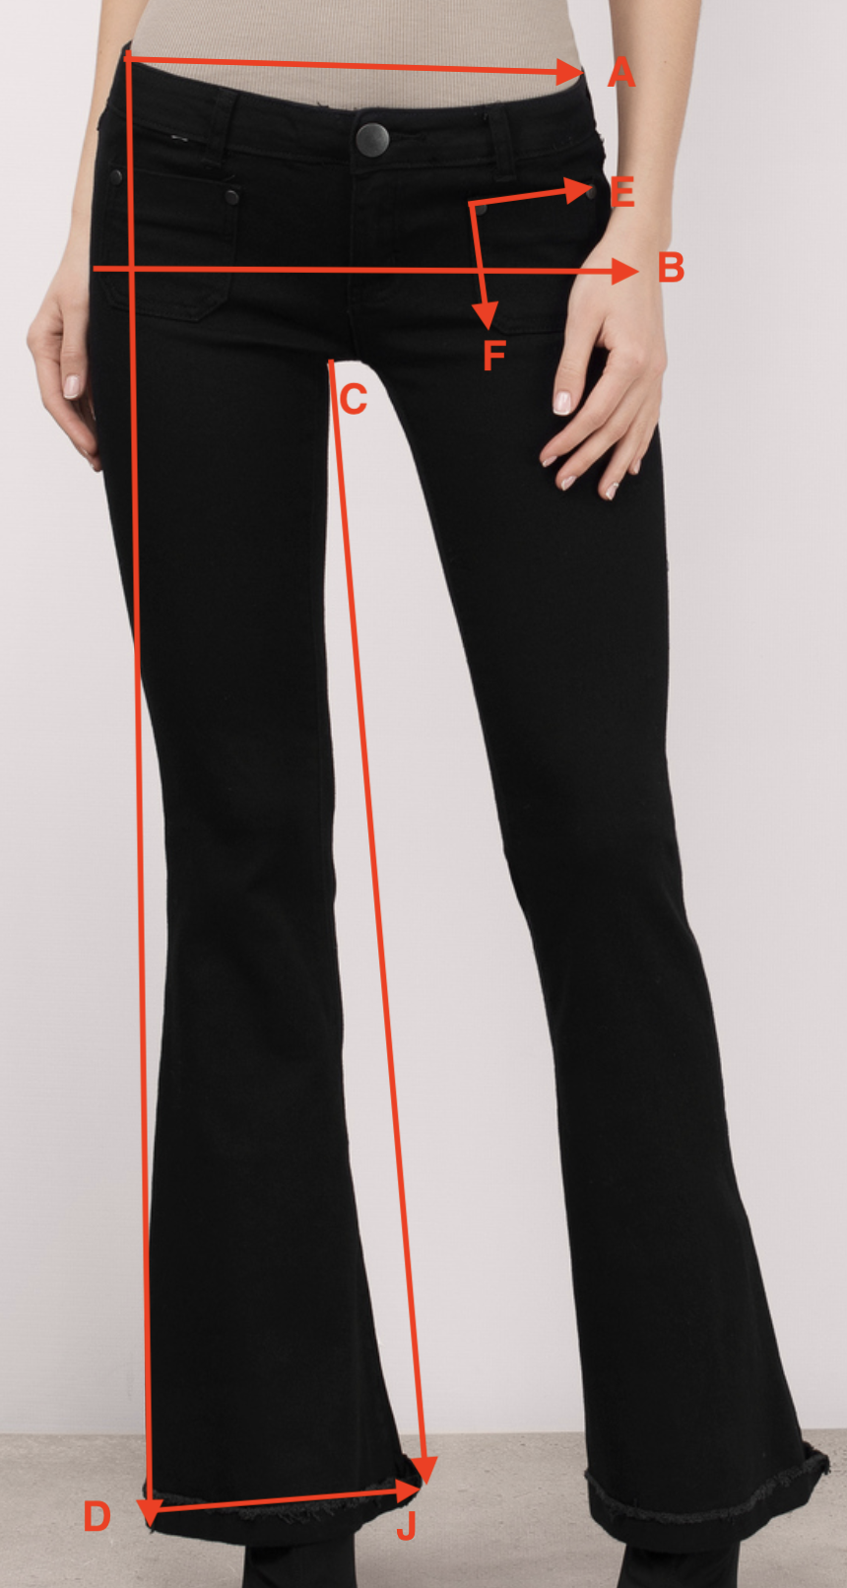

Style #: _DEL-113___ Design #: __HRGLS-122_____
Season: __Fall 2019___ Date: __1 Mar 2019________
Description: Delilah Flare Jean Color: Asphalt

Fabric #: __DM-001________________________
Type/Fiber content: ___96% cotton, 4% Lycra_____
Finish: __Asphalt Wash – piece dyed________________

Size:  Line | 24 | 25 | 26 | 27 | 28 | 29 | 30 | 31 | 32
A | 24” | 25” | 26” | 27” | 28” | 29” | 30” | 31” | 32”
B | 32”  33”  34” | 33.5  34.5  35.5 | 34.5  35.5  36.5 | 36  37  38 | 37  38  39 | 38.5  39.5  40.5 | 40  41  42 | 41  42  43 | 42.5  43.5  44.5
C | 32” | 32” | 32” | 32” | 32” | 32” | 32” | 32” | 32”
D | 40” | 40” | 40” | 40” | 40” | 40” | 40” | 40” | 40”
E | 3” | 3” | 3” | 3.5” | 3.5” | 3.5” | 4” | 4” | 4”
F | 4” | 4” | 4” | 4.5” | 4.5” | 4.5” | 5” | 5” | 5”
G | 5” | 5” | 5” | 5.5” | 5.5” | 5.5” | 6” | 6” | 6”
H | 5” | 5” | 5” | 5.5” | 5.5” | 5.5” | 6” | 6” | 6”
I | 2” | 2” | 2” | 2.25” | 2.25” | 2.25” | 2.5” | 2.5” | 2.5”
J | 21” | 21” | 21” | 22” | 22” | 22” | 23” | 23” | 23”

Back
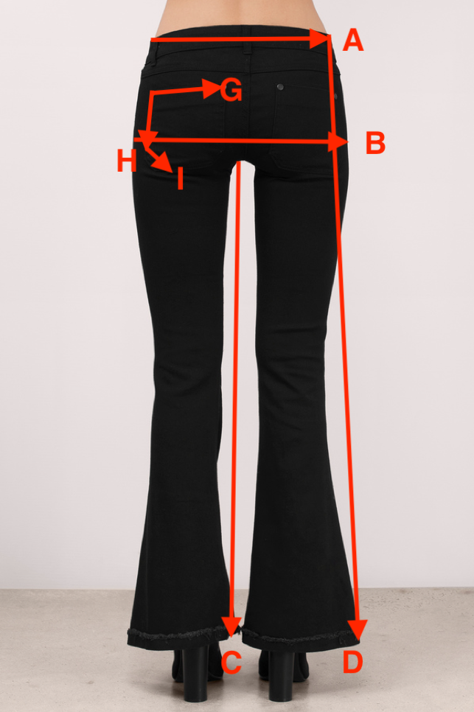
Findings/Trim
 | Type/Number | Color | Size | Amount
Thread | Gutterman000 | Black | Extra Heavy | 300 meters
Rivets | 1373-13 | Black | 9.2mm | 8

Hangtag: | Label:
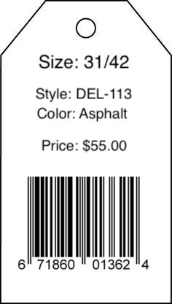

STYLE SPECIFICATION SHEET

Front
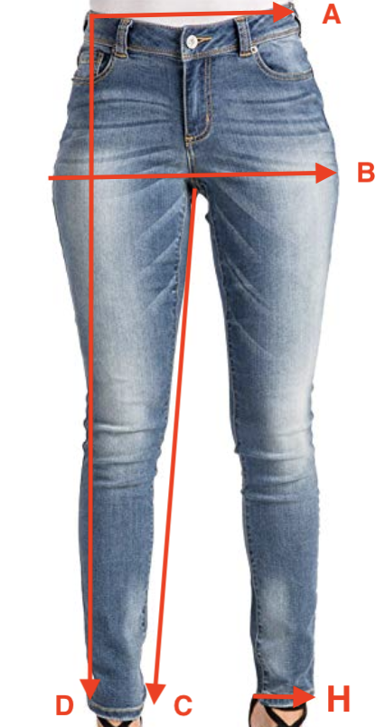

Style #: _JES-112___ Design #: __HRGLS-131_____
Season: __Fall 2019___ Date: __1 Mar 2019________
Description: Jessie Skinny Jean Color: Vintage Blue

Fabric #: __DM-001________________________
Type/Fiber content: ___96% cotton, 4% Lycra_____
Finish: __Vintage Wash – piece dyed________________

Size:  Line | 24 | 25 | 26 | 27 | 28 | 29 | 30 | 31 | 32
A | 24” | 25” | 26” | 27” | 28” | 29” | 30” | 31” | 32”
B | 32”  33”  34” | 33.5  34.5  35.5 | 34.5  35.5  36.5 | 36  37  38 | 37  38  39 | 38.5  39.5  40.5 | 40  41  42 | 41  42  43 | 42.5  43.5  44.5
C | 32” | 32” | 32” | 32” | 32” | 32” | 32” | 32” | 32”
D | 40” | 40” | 40” | 40” | 40” | 40” | 40” | 40” | 40”
E | 5” | 5” | 5” | 5.5” | 5.5” | 5.5” | 6” | 6” | 6”
F | 5” | 5” | 5” | 5.5” | 5.5” | 5.5” | 6” | 6” | 6”
G | 2” | 2” | 2” | 2.25” | 2.25” | 2.25” | 2.5” | 2.5” | 2.5”
H | 10” | 10” | 11” | 11” | 12” | 12” | 13” | 13” | 13”

Back
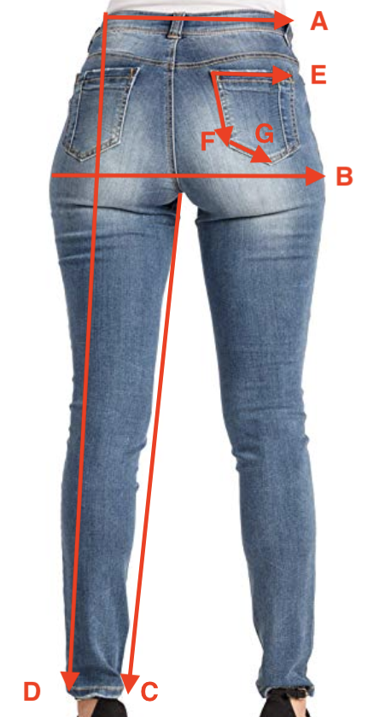
Findings/Trim
 | Type/Number | Color | Size | Amount
Thread | Singer 67120 | Old Gold | Heavy Duty | 300 meters
Rivets | RV9295D | Antique Brass | 9.2mm | 4
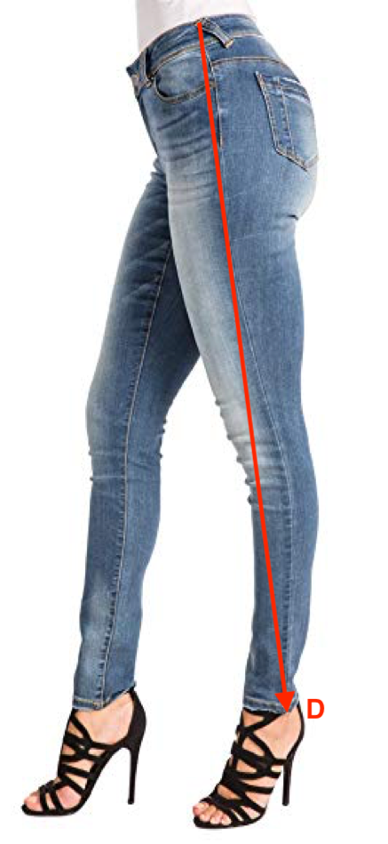
Hangtag: | Label:
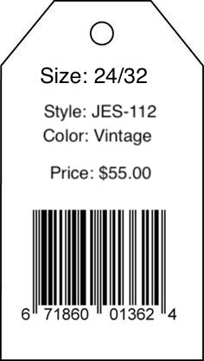

References
https://www.buckleguy.com/rv9295-double-cap-rivet-cap-9-2mm-post-9-5mm-antique-brass-solid-brass-100-per-bag/?gclid=CjwKCAiAkrTjBRAoEiwAXpf9CazAc_rIKsYBYO1UTBjN34O_T55-8QQt0sQJp_a1_JDrTdrYwAUP4BoCpxAQAvD_BwE
https://www.joann.com/heavy-duty-denim-jean-thread-150-yards-old-gold/1078526.html
https://www.moodfabrics.com/000-black-100m-gutermann-extra-strong-thread-100739?utm_source=google_shopping&gclid=CjwKCAiAkrTjBRAoEiwAXpf9CSZyB07UXBend9hZ5-7D8UXEtwCxvU1iqEnsu0635eFW8AMPXqRqIRoCSCgQAvD_BwE
https://www.ebay.com/p/Double-Cap-Rivets-Black-Plated-Medium-100-Pack-1373-13-by-Stecksstore/1637305159?iid=191295908503&chn=ps

